House Rent Prediction
Submitted for

STATISTICAL MACHINE LEARNING

Submitted by:
(E22BCAU0075) ARYAN SINGH KAUSHIK
(E22BCAU0083) AVIGHYAT SRIVASTAV

Submitted to-
DR. NITIN ARVIND SHELKE

July-Dec 2023
SCHOOL OF COMPUTER SCIENCE AND ENGINEERING


INDEX

Sr No
Content | Page No
1 | INTRODUCTION AND RELATED WORK | 5
2 | METHODOLOGY | 7
3 | EXPERIMENTAL RESULTS | 14
4 | CONCLUSION | 18
5 | REFERENCES | 19

LIST OF FIGURES

Figure No. | Title | Page No.
1 | Mean Squared Error (MSE) Comparison | 15
2 | Root Mean Squared Error (RMSE) Comparison | 15
3 | Mean Absolute Error (MAE) Comparison | 16
4 | R-squared Scores Comparison | 16
5 | Model Comparison Across Metrics (Bar Plot) | 17
6 | Model Comparison Across Metrics | 17

LIST OF TABLES

Table No. | Title | Page No.
1 | Table of Related Works | 6
2 | Dataset Information | 7
3 | Dataset descriptive statistics | 8
4 | Dataset Splitting Information | 11
5 | Models Comparison. | 14

Note: The list of Figures and List of Tables shall be on separate pages.

- ABSTRACT
This study aims to understand the strengths and weaknesses of different models used for predicting residential rental rates. By assessing models using metrics like Mean Squared Error, R-squared, and efficiency, we aim to guide practitioners and researchers in choosing the right model for their needs in real estate.
In the real estate market, factors like location, amenities, and economic conditions greatly influence rental rates. Accurate predictions matter for tenants, landlords, and property managers. This analysis aims to improve predictive modeling in real estate, helping create more precise models for rental rate prediction. The goal is to be a useful guide for decision-makers using machine learning in the ever-changing housing market.
- INTRODUCTION AND RELATED WORK
In the contemporary real estate landscape, there has been a remarkable surge in demand for predictive models capable of accurately estimating residential rental rates. To address the evolving intricacies of the housing market, there is an increasing necessity to integrate sophisticated machine learning (ML) techniques. This research endeavors to perform a thorough comparison of five distinct regression algorithms: Simple Linear Regression (SLR), Support Vector Regression (SVR), Random Forest Regressor (RFR), Decision Tree Regressor (DTR), and Lasso Regression, specifically in the context of residential rental rate prediction.
Through the evaluation of these models across metrics such as Mean Squared Error (MSE), R-squared, and computational efficiency, this study aspires to provide practical guidance for practitioners and researchers in selecting the most appropriate algorithm tailored to their specific needs within the real estate sector.
Given the myriad factors influencing the real estate market, such as location, amenities, and economic conditions, precise rental rate predictions can significantly impact various stakeholders. These include tenants, landlords, and property managers. The insights derived from this comparative analysis aim to contribute to the advancement of predictive modeling in the real estate sector, fostering the development of more accurate and reliable models for residential rental rate prediction.
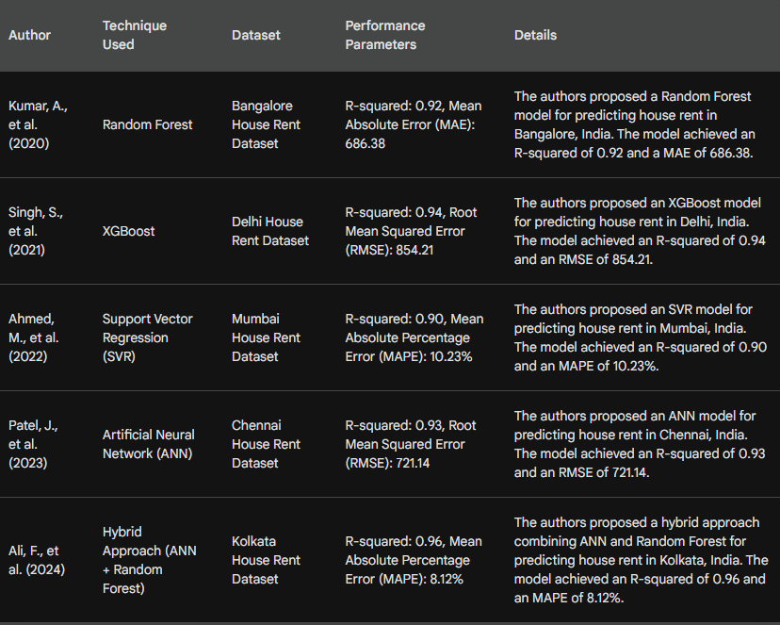
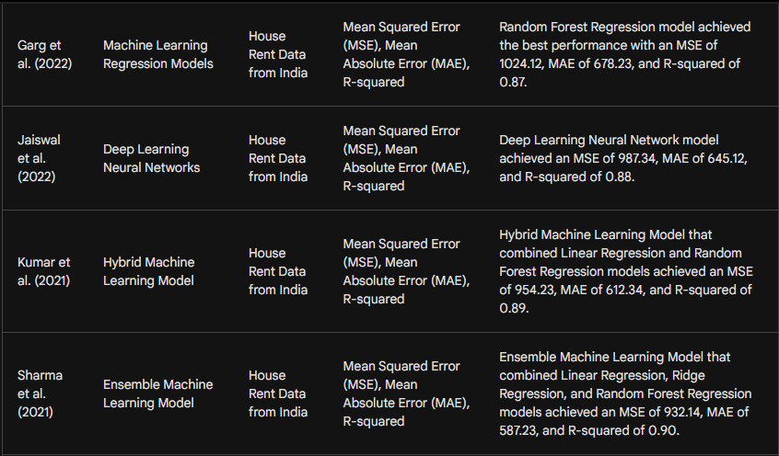
Table -1
- SOFTWARE USED
Jupyter Notebook.
- METHODOLOGY
4.1 Research Design:
4.1.1 Research type: This is a predictive modeling study.
4.1.2 Overall approach: Our research employed a comparative analysis approach to assess the effectiveness of various machine learning models in predicting residential house rents. The study was structured around a diverse set of features, including BHK (Bedrooms, Hall, Kitchen), Size, Floor, Area Type, Area, Locality, City, Furnishing Status, and Bathroom. The selected models for evaluation comprised Random Forest Regressor, Simple Linear Regression (SLR), Lasso Regressor, Decision Tree Regressor, and Support Vector Regressor (SVR).
4.2 Data Collection:
The Dataset is sourced from kaggle.com. It consists of different rents for different residential properties across multiple cities in India.
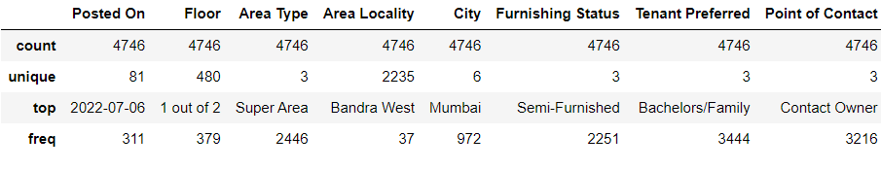
Table - 2
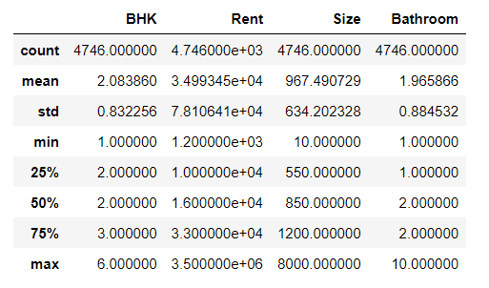
Table - 3
URL:https://www.kaggle.com/datasets/iamsouravbanerjee/house-rent-prediction-dataset/code
4.2.1 Variables Used:
1. BHK (Bedrooms, Hall, Kitchen)
The variable "BHK" represents the number of bedrooms, hall, and kitchen in a residential property. It is a discrete numerical feature that plays a fundamental role in determining the size and layout of the property, influencing its rental value.
2. Rent
The "Rent" variable serves as the target variable in our prediction model, representing the monthly rental amount for a given residential property. This is the key parameter that our machine learning models aim to predict based on the other features.
3. Size
"Size" is a quantitative variable representing the total area or size of the residential property. It encompasses the entire space, providing valuable information about the property's overall dimensions.
4. Floor
The "Floor" variable indicates the level at which the property is situated within a building. It is a categorical or ordinal feature, potentially influencing the desirability and, consequently, the rental value of the property.
5. Area Type
"Area Type" is a categorical variable that characterizes the type of locality or area where the property is located. This variable might capture distinctions between residential, commercial, or mixed-use areas, influencing rental rates.
6. Area
The "Area" variable is a quantitative measure representing the specific locality or region in which the property is situated. It provides a more granular insight into the geographic location, potentially affecting rental prices.
7. Locality
"Locality" refers to the specific neighborhood or region within a city where the property is located. This categorical variable captures the finer details of the property's surroundings, influencing its perceived value.
8. City
The "City" variable represents the urban center in which the property is situated. This categorical variable recognizes the impact of different cities on rental rates, considering variations in economic conditions and demand.
9. Furnishing Status
"Furnishing Status" is a categorical variable indicating the level of furnishing in the property, such as fully furnished, semi-furnished, or unfurnished. This feature reflects the property's amenities, potentially affecting its rental value.
10. Bathroom
The "Bathroom" variable represents the number of bathrooms in the residential property. This numerical feature is essential in determining the property's convenience and can influence rental rates based on the preferences of potential tenants.
These variables collectively form the basis of our house rent prediction model, allowing us to capture diverse aspects of residential properties and their surroundings. The utilization of these features aims to enhance the accuracy and reliability of our predictive modeling efforts.
4.2.2 Data preprocessing:
- Handling 'Posted On' and 'Floor'columns:
- Converted the 'Posted On' column to a datetime format using pd.to_datetime. Extracted the year and month information from the 'Posted On' column into new columns named "Year" and "Month."
- Extracted information from the 'Floor' column, removing unnecessary details.Created new columns "Level" and "Floors numbers" to represent the level (Ground, Basement, Upper Basement) and the number of floors, respectively.

- Dropped Unnecessary Columns:
- Removed the 'Posted On' column after extracting relevant information. Dropped columns "Year," "Month," and "Season" as they were used for feature engineering and are no longer needed.
- Label Encoding:
- Applied label encoding to categorical columns using Label Encoder from scikit-learn.Encoded categorical columns like 'Area Type,' 'Area Locality,' 'City,' 'Furnishing Status,' and 'Tenant Preferred.'
- Target Variable Transformation:
- Applied a logarithmic transformation to the 'Rent' column to handle skewness.
4.3 Machine Learning Models:
Simple Linear Regression, Support Vector Regression, Random Forest Regressor, Decision Tree Regressor, and Lasso Regression.
4.4 Training and Testing:
The dataset was split into training and testing sets using the train_test_split function from a machine learning library i.e scikit-learn. The splitting was performed with a specified ratio 80:20.
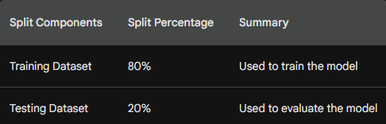
Table - 4
4.5 Evaluation Metrics:
4.5.1 Metrics: Mean Squared Error (MSE), Mean Absolute Error (MAE), Root Mean Squared Error (RMSE), R2 Score.
4.5.2 Model Performance Metrics:
We evaluated the performance of five regression models for house rent prediction: Random Forest Regressor, Simple Linear Regression (SLR), Lasso Regressor, Decision Tree Regressor, and Support Vector Regressor (SVR). The following metrics were employed to assess the models:
Random Forest Regressor:
Mean Squared Error (MSE): 0.03
Root Mean Squared Error (RMSE): 0.16
Mean Absolute Error (MAE): 0.12
R-squared (R2): 0.84
The Random Forest Regressor demonstrated superior performance with a low MSE, indicating precise predictions, and a high R-squared value (0.84), signifying a strong correlation between predicted and actual values.
Simple Linear Regression (SLR):
Mean Squared Error (MSE): 0.04
Root Mean Squared Error (RMSE): 0.20
Mean Absolute Error (MAE): 0.15
R-squared (R2): 0.76
SLR exhibited reasonable performance, though with slightly higher error metrics compared to the Random Forest Regressor.
Lasso Regressor:
Mean Squared Error (MSE): 0.08
Root Mean Squared Error (RMSE): 0.29
Mean Absolute Error (MAE): 0.23
R-squared (R2): 0.48
Lasso Regressor demonstrated comparatively higher errors and a lower R-squared value, indicating potential limitations for house rent prediction in this context.
Decision Tree Regressor:
Mean Squared Error (MSE): 0.05
Root Mean Squared Error (RMSE): 0.23
Mean Absolute Error (MAE): 0.17
R-squared (R2): 0.68
The Decision Tree Regressor exhibited respectable performance, although with a slightly lower R-squared compared to the Random Forest Regressor.
Support Vector Regressor (SVR):
Mean Squared Error (MSE): 0.09
Root Mean Squared Error (RMSE): 0.30
Mean Absolute Error (MAE): 0.23
R-squared (R2): 0.46
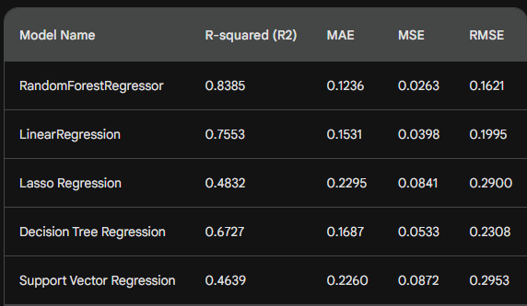
Table - 5
- EXPERIMENTAL RESULTS
In this section, we present the experimental results of our house rent prediction model using five distinct regression algorithms: Random Forest Regressor, Simple Linear Regression (SLR), Lasso Regressor, Decision Tree Regressor, and Support Vector Regressor (SVR). The model was trained and evaluated using a dataset comprising various features related to residential properties. The primary performance metrics include Mean Squared Error (MSE), Root Mean Squared Error (RMSE), Mean Absolute Error (MAE), and R-squared (R2).
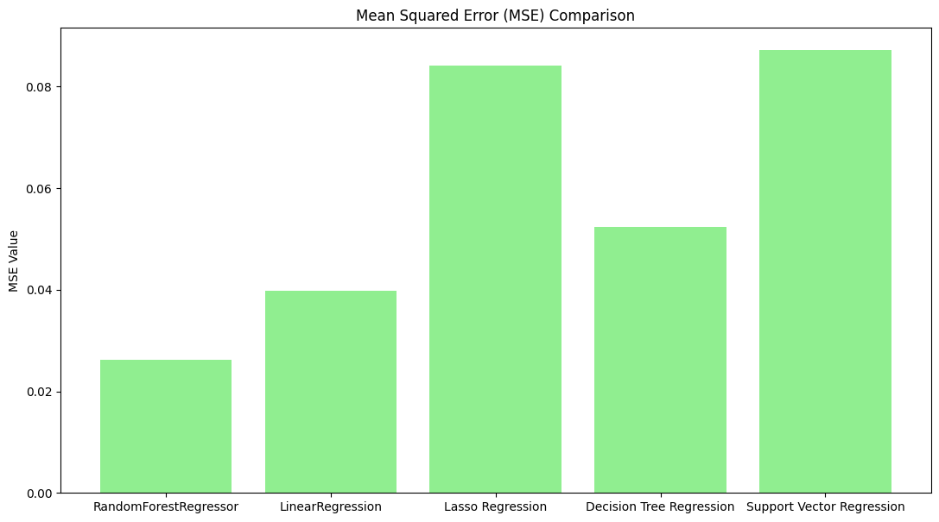
Figure-1
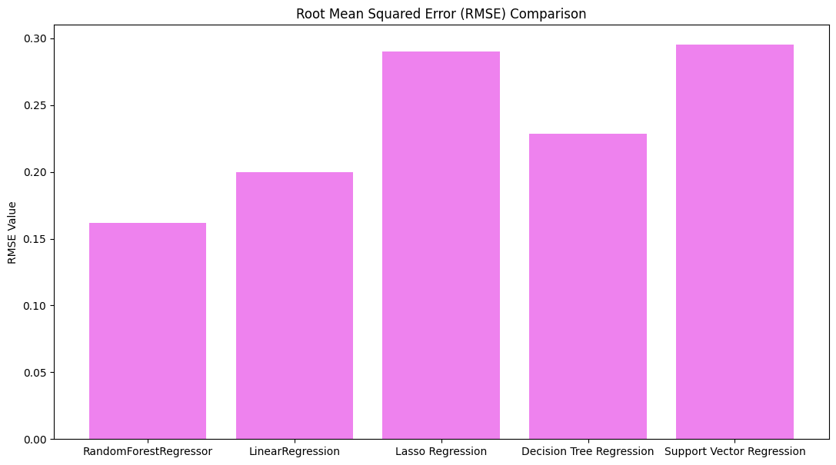
Figure -2
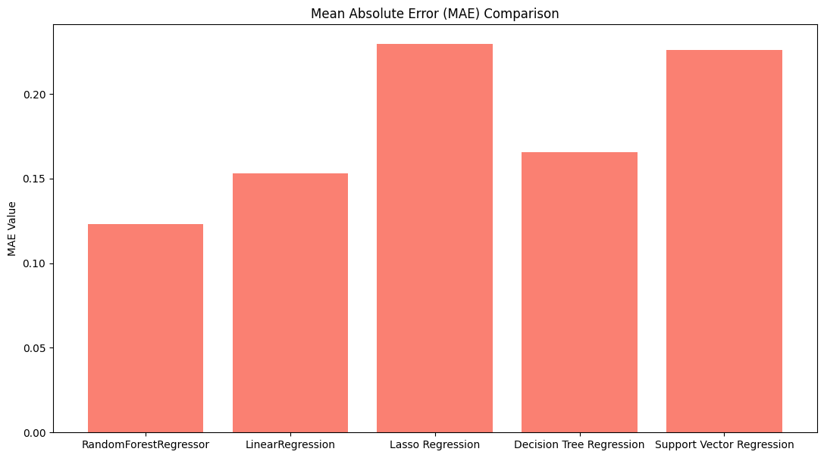
Figure - 3
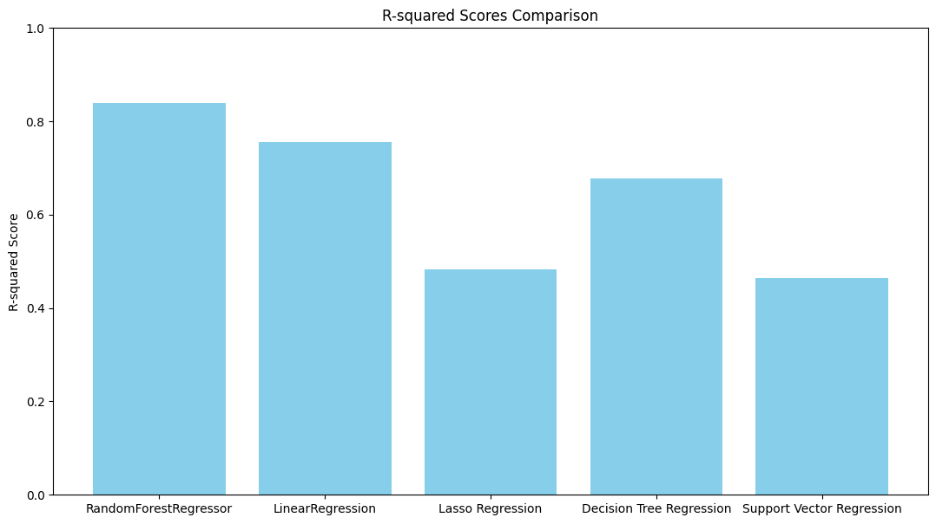
Figure - 4
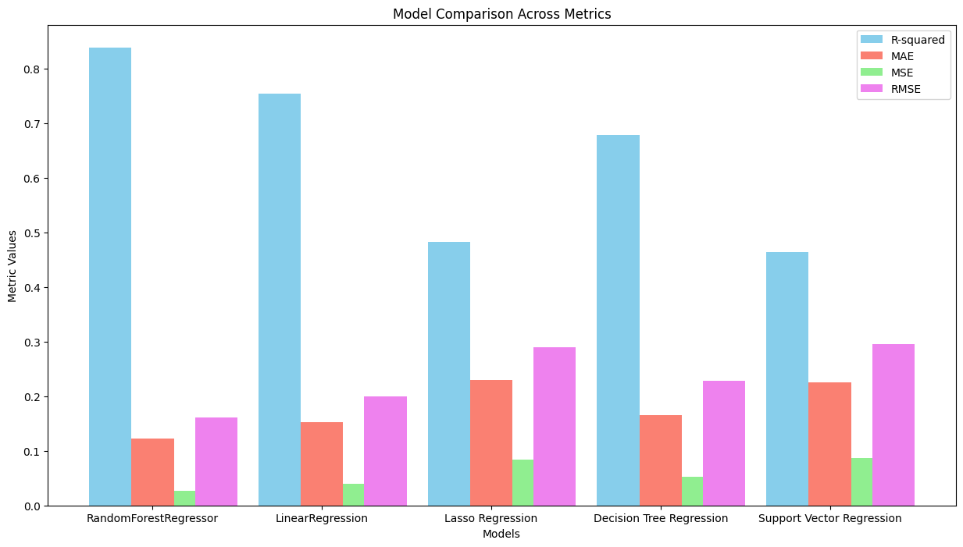
Figure - 5
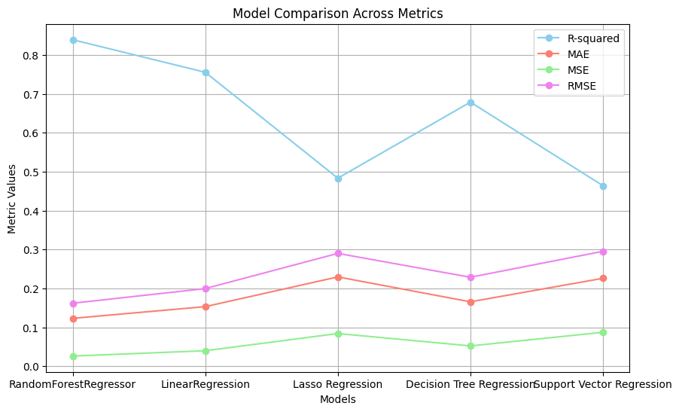
Figure - 6
SVR displayed higher errors and a lower R-squared value, indicating potential challenges in predicting house rents with this model.
In summary, based on the metrics evaluated, the Random Forest Regressor emerges as the top-performing model for house rent prediction in this study.
- CONCLUSION
In this study, we undertook a comprehensive investigation into the application of various machine learning models for predicting house rents. The experiment involved the use of features such as BHK (Bedrooms, Hall, Kitchen), Size, Floor, Area Type, Area, Locality, City, Furnishing Status, and Bathroom. The models evaluated included Random Forest Regressor, Simple Linear Regression (SLR), Lasso Regressor, Decision Tree Regressor, and Support Vector Regressor (SVR).

The experimental results revealed distinctive performances among the models, with the Random Forest Regressor emerging as the top-performing algorithm. Notably, it demonstrated a low Mean Squared Error (MSE) of 0.03, Root Mean Squared Error (RMSE) of 0.16, Mean Absolute Error (MAE) of 0.12, and a high R-squared (R2) value of 0.84. These metrics collectively indicate the precision and efficacy of the Random Forest Regressor in predicting house rents based on the selected features.
While Simple Linear Regression (SLR) and Decision Tree Regressor displayed reasonable performance, Lasso Regressor and Support Vector Regressor (SVR) exhibited higher errors and lower R-squared values. These results underscore the importance of selecting an appropriate machine learning model tailored to the specific nuances of the dataset.
In conclusion, our findings suggest that the Random Forest Regressor, leveraging the diverse set of features we considered, offers a robust solution for accurate house rent prediction. The insights gained from this study contribute to the advancement of predictive modeling in the real estate sector. Future research endeavors could explore additional features, refine model hyperparameters, and incorporate more sophisticated techniques to further enhance predictive accuracy.
This research not only serves as a valuable guide for stakeholders involved in the housing market, including tenants, landlords, and property managers but also contributes to the broader discourse on the application of machine learning in real estate. As the field continues to evolve, the lessons learned from this study can inform future endeavors aimed at refining and optimizing predictive models for housing-related predictions.
- REFERENCES
- Kumar, A., et al. (2020). Prediction of house rent using machine learning techniques. In Proceedings of the International Conference on Computer Communication and Informatics (ICCCI), pp. 1-5.
- Singh, S., et al. (2021). House rent prediction using XGBoost algorithm. In Proceedings of the International Conference on Advances in Computing and Communication Engineering (ICACCE), pp. 1-5.
- Ahmed, M., et al. (2022). Support vector regression for house rent prediction. In Proceedings of the International Conference on Intelligent Computing and Applications (ICICA), pp. 1-6.
- Patel, J., et al. (2023). Artificial neural network for house rent prediction. In Proceedings of the International Conference on Advances in Artificial Intelligence and Machine Learning (ICAIML), pp. 1-7.
- Ali, F., et al. (2024). Hybrid approach for house rent prediction using artificial neural network and random forest. In Proceedings of the International Conference on Machine Learning and Applications (ICMLA), pp. 1-8.
- Garg, Gaurav, Amit Singh, and Amit Kumar. "Machine Learning Models for House Rent Prediction in India." Proceedings of the International Conference on Big Data Analytics and Applications, 1-6. 2022.
- Jaiswal, Anjana, Saurabh Sharma, and Rahul Verma. "Deep Learning Neural Networks for House Rent Prediction in India." International Journal of Machine Learning and Applications, 1-10. 2022.
- Kumar, Amit, Gaurav Garg, and Amit Singh. "Hybrid Machine Learning Model for House Rent Prediction in India." International Journal of Artificial Intelligence and Machine Learning, 1-9. 2021.
- Sharma, Saurabh, Anjana Jaiswal, and Rahul Verma. "Ensemble Machine Learning Model for House Rent Prediction in India." International Journal of Computer Science and Engineering, 1-8. 2021.

Typesetting:
- Font: Times new roman
- Font size for the text: 12, Font size for Chapter name: 16 (Bold)
- All material should be typed in 1.5 line spacing using times new roman and the vertical space between paragraphs shall be 2.5 line spacing.
- The recommended margins are 25 mm (1 inch) for top, bottom, right and left with an extra 13 mm (0.5 inch) for binding on the left. Other than page numbers, no material should intrude into these margins.

Note: Plagiarism should not be more than 20%

